ABC of a Medieval Church - Second Edition
MARTIN RENSHAW

From reviews of the First Edition:
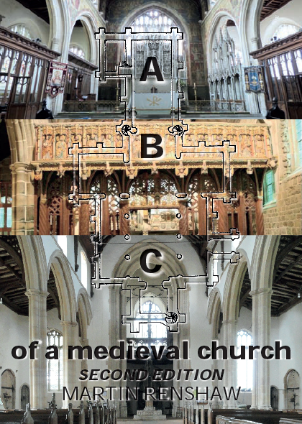
‘Anyone who revisits a medieval church after having read this book will see it in a different light’
Michael Fisher, Pugin Society
‘Refreshing and informative’
John Rowntree, Monastic Musicians
‘Stimulating and useful’
David Meara, Society of Antiquaries Journal
‘Fascinating’
Christopher Howse, Daily Telegraph
‘Informative and enjoyably, refreshingly, honest’
Len Dunleavy, Organists’ Review

ISBN 9780956710277 (December 2019)
124 pages, many b&w illus., 8 pp colour

ABC of a medieval church - a book for all those who look after and love medieval churches. Distilling the results of ten years of documentary research and survey visits to over 800 selected churches, this book sets out a new approach to its underlying subject : how all medieval church buildings, irrespective of their architecture, were designed functionally. By taking account of what has been lost, as well as what can still be found by careful search, it explores how the daily working demands made on medieval churches were accommodated. Understanding the ways in which this was done seems to the author to be crucial to the protection and conservation of historical evidence in England's unique heritage of medieval churches.
The second edition includes a preface and incorporates new ideas and insights from ongoing research.

ORDER FORM
Name ………………………………………………………………..………………………………………..…..….... Title …..…….
Address ………………………………………………………………………….……………………….….……..……………………..
…..................................................................................................................................................................
…..................................................................................................................................................................
Postcode ……………………………………...….……. Country …………………….………………………………………………
E-mail ……………………………….…………………………..……………………….… Tel ……………………………………….
Please send me ......... Cop(y/ies) of ABC of a Medieval Church (Second edition) at £8 each.
Postage and packing for single copies: UK, £2.50; EU, £5.00; Rest of the world, £8.00
If multiple copies are required please contact Martin Renshaw for p&p costs.
Payment by bank transfer: - please contact Martin Renshaw for details.
E-mail the completed order form to: renshaw.martin45@gmail.com

