1 Stoke-by-Clare, Suffolk

Physical evidence found on visits supported later by previously-unpublished archival evidence
Notes made following first visit, 16 July 2011: remnants of a gallery structure found on NE chancel wall
At the east end of the north chancel aisle there is a two-storey building. The present ‘organ chamber’ west of this, formerly a chapel, has a Marian doom painted on its east wall, and south of this is an opening, 4 ft 10 ins high and 20 ins wide, like a rood-loft doorway, with stone surrounds. It starts 7 ft from the ground, and three steps set within the thickness of the wall lead towards the chancel through an arch whose cill is 8 ft above chancel floor level.
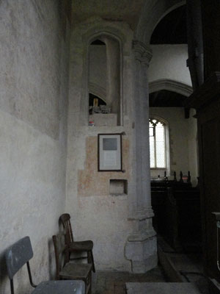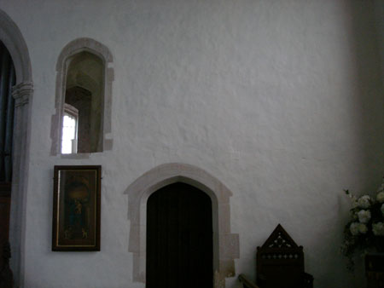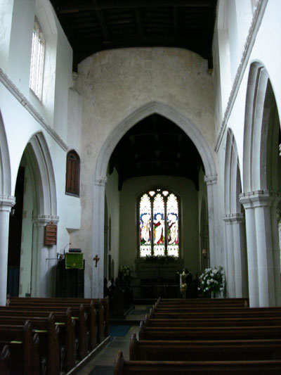
Opening with 3 steps up now to ... ...nowhere but the lower cill on the same level View of chancel and east window
as three horizontal cut-off joists
Remnants of at least three now cut-off horizontal joists can be seen in the wall between a door that leads into the NE building and the east wall of the sanctuary suggest that there was a platform also 8 feet high here. It might have supported an organ, there being relatively restricted floor space: much of the chancel and the south chancel aisle [the former Lady aisle?], which has an altar at its east end, being now, and presumably earlier, taken up with stalls.
The rather narrow chancel has a large east window which stops 32 ins from the north wall, so allowing any platform on the north wall to be up to about 32 ins deep overall, including a balustrade.
The overall height of the chancel north wall of about 20 ft would allow any structure on a platform 8 ft high to be up to about 12 ft tall. This is the only wall in the eastern part of the church that is available to accommodate an organ.
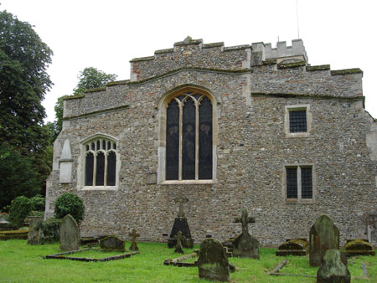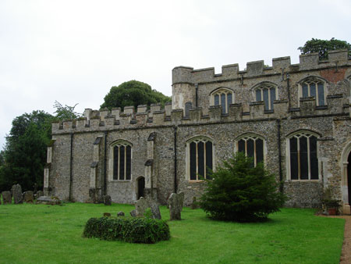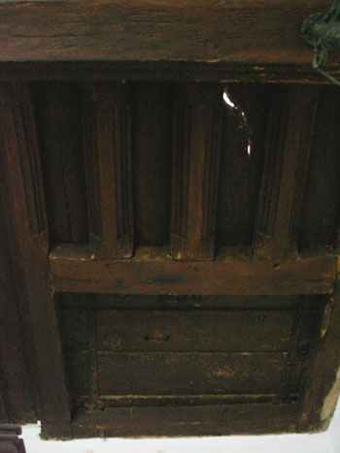
Two-storey vestry off north side of the North chancel aisle with 2-storey vestry at Trap door in lower vestry ceiling
chancel with barred windows far east end
Behind it is the upper storey of the NE building, accessible through a trap door in the NW corner of the lower floor and lit only by a small eastern window with a strong iron grille; might have been a safe-room.

Archive: The bishop's injunctions, set out in a letter (now at Corpus Christi College Cambridge) in 1526 ordered that if the dean did not reside he was only to receive £20 a year out of the profits, according to the statutes; that the chancel of Clare was to be repaired at the dean's expense, before next All Saints' day; that the janitor was to reside and see to his duty, otherwise to forfeit his salary; that one of the clerks was to sleep and remain all night in the vestry; that the verger was to be in attendance and exercise his office in the same manner as at the collegiate church of St. Stephen, Westminster, or of Windsor ... Other injunctions related to inventories, custody of seals, the recovery of the muniments, &c.

So, the NE building comprised a vestry – some contents of which are detailed in the 1534 inventory below.
Notes made following second visit, August 2011
There are three obvious beam remnants [there may be more to the west to support the access gallery beyond the doorway?], cut off close to the wall and partly plastered over, each about 5 ins wide by 4 ins high. The most westerly of these is set 26½ ins to the east of the centre of the doorway; the other two are set at 24 inch centres towards the east from this. Of these three, the first and third go right through the 25 ins thick wall into the vestry. They have nothing to do with the structure of the inner room’s ceiling, which is 10 ft 6 ins high from its floor level.
The overall possible width of the platform/gallery, from the eastern edge of the arch between chancel and north chancel aisle (called the Lady Chapel in the church guide) to the east wall, is 16 ft 2 ins, that is, 6 ft 6 ins from chancel aisle eastern opening to the centre line of the door opening and a further maximum of 9 ft 8 ins from the centre line of the door to the east inside wall. Probably the three joist stumps took the main weight of the organ, about two-thirds of the way along the blank wall. We really need to go back and investigate any more relics of the structure, including the gangway which led from the opening to the area of the three joists. Perhaps it was like the south parclose gangway still in Dennington church?
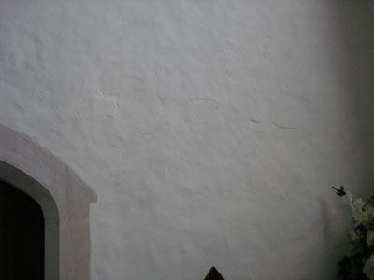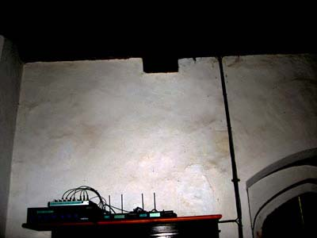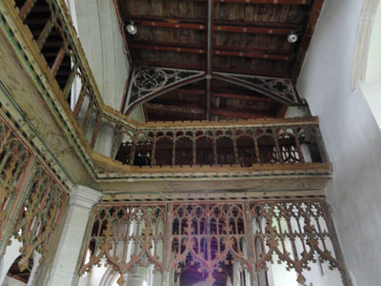
Three cut-off joists Two outer joists come through to vestry South parclose screen loft at Dennington
right hand one partly under vertical pipe

Three joists Two outer joists through to vestry Parclose gangway at Dennington
(one on right partly behind vertical pipe)

Notes made following third visit, October 2012
There is a mark 8 ins tall by 5 ins wide on the north chancel wall (possible site of wind-trunk hole?) 11 ft 4 ins to its underside above the chancel floor and 3 ft 3 ins above the platform joist stubs. We gained access to the upper vestry with the help of Roger McKenny and saw a floor covered in plastic (so no visible signs of bellows etc – yet ...) and that the south wall of the upper floor was largely plastered.
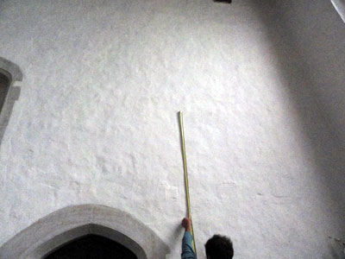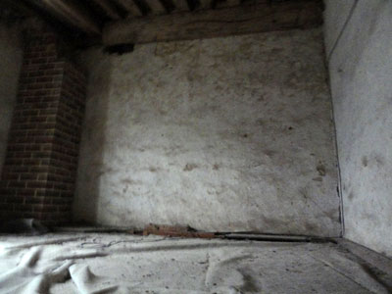
Position of mark above outer joist Close-up of rectangular mark (in centre) Vestry upper floor, plastered south wall

continued: Nothing else was visible in the upper vestry at all. We will ask to investigate and if necessary radar-probe the wall for signs of the wind-trunk hole on the upper room side, and its position in relation to the organ on the chancel side. And we will need to look carefully at the floor under the plastic covers to see if there are any signs of fixings.

Archive: the inventory of 1547/8 (on closing down the College) is well known, but the following is not, and is more detailed, especially as regards the organ and children’s music and the organ ‘standing’, i.e. high up, in the chancel.... There are no extant churchwardens’ accounts.

Inventory 1 July 1534
From Matthew Parker’s note-books (collected by MR James) in Corpus Christi College Cambridge
(MSS 108) – from photo/scans sent from the library by internet:
P181: Inventarium factum 1 julii 1534 de omnibus localibus ornamentis caeteris bonis ecclesiae collegiate de Stoke juxta Clare … [inventory made 1 July 1543 of all the places where the ornaments and goods of the collegiate church of Stoke by Clare (are kept)]
P182: [Images]; p183 [images, candlesticks]; p184 [pax, box, holy water, little purse]; p185 potell, Jocalia quarto
P186: [books]
Libri ptinetes ad collegium de Stoke [books belonging to Stoke College]
In pimis 2 masse boks wrytyn in vellym … [First, two missals written on vellum/parchment]
Item other masse boks of vellym writtyn bon’t wt lether / And iij other masse boks inprityds in pap. [other missals written on vellum and bound in leather / And three other missals printed on paper]
Item A Antiphanys wrytyn and notyde [with notes] in vellym / [bound] wt lether[,] for the qure [choir]
[the following items were deciphered and checked with help from Suzanne Paul, at CCCC:]
Item ij boks contaynyng grayles [graduals] & verses for ye Organs
Item ij lytyll boks for ye chyldern to syng verses apon
[this entry seems to confirm that the routine method was to sing ‘verses’ between the children and perhaps the organ]
Item ij boks for ye martheloge [lives of maryrs] wrytyn in pchement
Item ij manuells ye on covert with rede lether withowt claspes [two manuals, one covered with red leather without clasps] And ye other with whyte lether with claspes of latyn [And the other [covered] with white leather with latten clasps]
Item iiij boks ij for þe [the] Gospells And other ij for the Epistoles
Item 3 ...[?]... Graylys wrytyn and noted in vellym / And bont wyth lether belongyng to yr quere / Item A qualjs wrytyn & notyd in sot ...[?]... for or Lady masse
P187: Item ...
And a lyttel ...[?]... old boke wrytyn in pchment to … legents … to dige domino robt wt whyt lether & lynd wt /// lackyng A claspe
And a boke for the Venites wrytyn in pchment and noted … de invitations in … claspes ….pchment
And iij boks of hymns printed on papr notd
P188: [ordinals] And ij boks of pmondys [?]
And a gret pksong [pricksong = polyphony] booke wrytyn & noted in pchment ….so passio dm … wt whyt lether wi ...[?]... claspys of lattyn And A boke of pksong parte pap parte pchment
[other furniture in the chancel:]
And A ...[?]... lectorn in ye quere of tymber for ye ...[?]...
And iii ...[?] … [?]...and … tabyll to laye the copes on and ij ...[?]... for ye … to sett [sit] on
Itm a grete lectorn [lectern] in ye quere of tymber for ye ...[?]... Rector [chori ?]…
Itm wt a tabyll to ...[?]...
Itm xij sirplets [surplices] for ye querestors [choristers]
Itm A gret plumet of lede [lead weight] to counterpass [counterpoise] ye vayls [veils] in lent
Itm A vayle of lymyd [painted] cloths to hange [in front of] ye hyge Auter [high altar] in le[n]t wt A red staynyd [painted] …brossa[?]
Item ij … cloths staynyd wt tokyns of ye passion for the passion tyme
And libri & In choir [?] [And books, and also books in the choir [stalls]]

P189: … [half way down]
Itm in ye rode lofte a gret payer of Organs [a large organ in the rood loft – presumably on either the south or north side across the aisles]
Itm An other payer standyng in ye quere of organes [another organ high up in the choir]
Itm An other payer in our lady chapll of smale Organs for our lady masse [another small organ in the Lady chapel for use at the Lady mass]
PP190-206: corpalia, vexilla, payls [altar ornaments, copes, chasubles, cloths; flags; pails]
P206 [top]: Itm viij saqynets [?]
Itm 1 [?] bassy[n]s of copar [copper basins] in … wt … for A … in
Itm A sapulqs [Easter sepulchre] framed in tymber
Itm A hasor [?] of tymber for candals in t’by …
Itm A payle for a flotyll [?]
Itm a chast in ye hyer wt bandys of year[n]s [a chest in the upper floor with iron reinforcements]
Itm ij clothes of dornyck [dornick cloth] hangyng …
Itm A … lytyl cheste lackyng lock for syngyng brede [a small cupboard without a lock to keep ‘singing bread’ in]
Itm A case in ye vestre ...[?]... of .teyne... brede for ye cor… to hang yn
[a case in the vestry of tin [?] for bread for consecration to hang in it...]
Itm in ye Vestre A great ...[?]... chyste bondes wt blake lether wt bandis of yarm [yron ?] wt ij locks & ij handlys on ...[?]... each side and on at ...[?]... ende [in the vestry, one large chest bound with black leather with iron reinforcements with two locks and a handle at each end]
Itm in same Vestre A cheste of tymber wt on playn locke to kepe ye chalys in And A ...[?]... for to kepe chandyl in [in the same vestry, one wooden chest with a plain lock to keep the chalice in, and one[?] to keep candles in]
Itm in ye same vestre A gret cheste for ornaments wt ij locks
[in the same vestry one large chest to store ornaments in with two locks]

So it seems as if the 1534 inventories refer to ‘a vestry’ and a ‘hyer [floor]’, which presumably are the two floors in the NE building. The roof joists of the upper floor, visible from the lower floor, are finely made with mouldings – was this part of the repair ordered in 1526 to be made by the then Dean of the College? – and presumably made to keep the upper floor as safe as possible – though in fact the inventory does suggest that precious things (the chalice and ornaments) were kept on the ground floor too.
P207 (206a):
Itm vj cuppes … of tyn
Itm A pax of cop[per] gylt [gilt] wt ye ymage of ye cafix [crucifix] our lady and saynt John
Itm ij holy water stocks of latyn [‘latten’ basins]
Itm A fthrys cotaynyg dyvers [various] ... [?] … of tymber
Itm ij paynted clothes for ye hyge Aulter of damaske w… on [one] fac [face] on pto & the other for the lawpte [frontal] of ye Aulter
Itm A bottell of tyn [tin or pewter flagon] for syngyng wyne [wine for the sung mass]
Itm A great carpet to spred before the hyge Aulter [end]

INVENTORY made 18 March 1547/8, when the College was closed down; items are priced for sale.
Note – here two organs are mentioned in the Lady chapel, but the inventory is not so detailed as the previous (1534) one.... (from‘58’/LV (East Anglian Notes & Queries Dec 1896, p305) :
P307: Under ‘Bookes &c’ :
Itm vj mass boks written & print. Itm viij antiphonars wrytten. Itm viij grayles wrytten. Itm iij legends wrytten & printed. Itm xij processioner[s]. Itm iij bokes of hymnes. Itm bokes for the organ. Itm too manuells. Itm ij for the venytees. Itm an ordinat, & martiloge, pc – xxvjs viijd
Itm iij great candelstickes of latten – iiij li
Itm another in our lady chapell – xs
Itm a paire of organs in ye rode loft - xxs

[p 308] Itm a paire in the quere – xxvjs viijd
Itm ij paire in the lady’s chapell – xxs …
…Itm the waynscott in the rode loft and round about the church pr cs [?priced at 100 shillings]
Itm a clock parfect strykyng on ye great bell
Itm the bokes in the library: wt ther chenes, stalls, yrons and waynscott – v li

Further notes made following third visit, October 2012
The rood loft stairs, lit by a 15 inch window from the north chancel chapel, are quite wide (lower doorway inside width 26½ inches; height 65½ inches) up to rood loft level, and eventually lead up with narrower steps to the aisle and nave roofs. The bell on top of the tower in the open may be the curfew one that summoned priests back to the College house? Unless that was at the College ... Or was it the ‘great [clock] bell’? (see above)

Earlier, I had written: I wonder if the idea, virtually taken for granted by late Victorian and modern Edwardian scholars, that church organs [in the eastern part of England – see the Ashburton case study for Devonshire evidence] were generally on rood lofts (for which there is some evidence, as here at Stoke, but much more contrary evidence elsewhere) comes from the fact that they were on chancel galleries at about the same height as the lofts and possibly accessed from them? Even now, people talk about ‘organ lofts’ when they just mean the organ itself, or even just its console (a modern term) – and this seems almost like a folk memory. In fact it would be hard to think of any organ in England at present which is actually in a loft, that is, a medieval or later structure specially and specifically made to support an organ off the floor. (I don’t mean a high organ chamber, or an existing west gallery, or a gallery made for charity children, singers etc, or a pulpitum whose purpose is to close off the west end of a chancel in a large multi-use cathedral or pilgrimage church, or a detached console set above choir stalls.)

On-the-spot notes: the stalls are arranged like choir stalls now, and the priest’s desk may include the base of the rood screen.
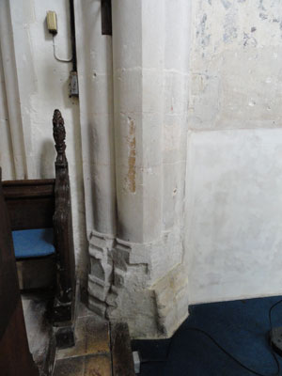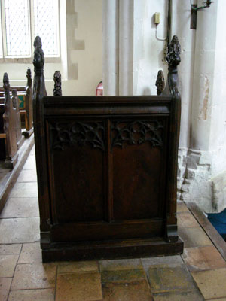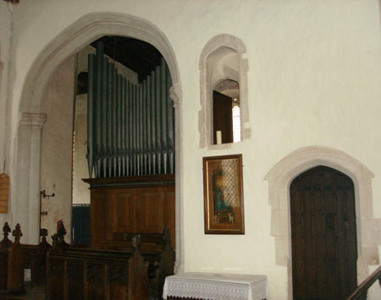
Choir stalls now end with no return Priest’s desk made from base of Four-centred arch in the north chancel
by the southern chancel arch - cuts in rood screen?
base show where rood screen fitted

The church guide says that the chancel is older than the nave, and it may be that the chancel’s fabric is older, but the four-centred arches into the chancel aisles suggest that the chancel was rebuilt (for its function within the College set-up?) in the early 16th century. It was perhaps then that the organ platform/loft was installed. (The similarly-arranged structure at Walberswick dates from the time when a small chapel there was greatly enlarged into the present, now ruined, structure during the last years of the 15th century.)

Further work will be done in the church and will be reported on, on this website. From the evidence above, although it is circumstantial, it is perhaps now possible to suggest that the church was in fact the chapel of Stoke College. The late perpendicular style of the nave and most of the chancel suggests also that they were rebuilt for or by the College. © Martin Renshaw 2013 http://soundsmedieval.org

